
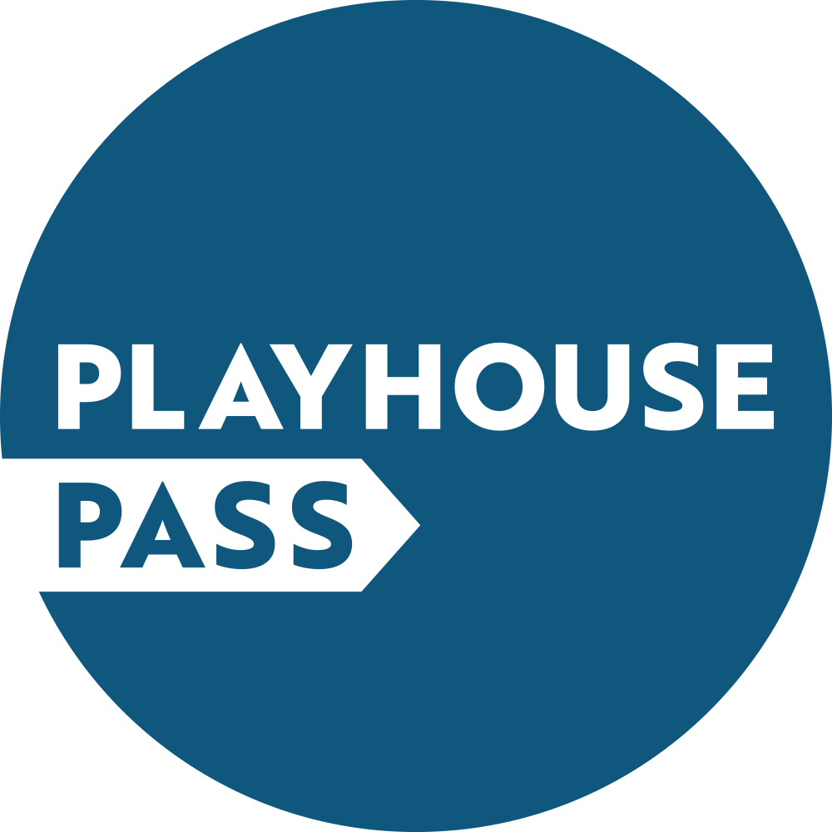

Make membership simple with an annual Direct Debit

It’s easier to manage your Playhouse Pass Membership by setting up a Direct Debit – taking the inconvenience out of future renewals. Your payment will be taken annually until you tell us otherwise. So you can keep your membership active without having to do a thing.

In addition, pay by Direct Debit and your annual membership fee costs 10% less. So standard membership currently costs just £36. If the fee should change in future, we will notify you before processing payment.
It will only take you a few minutes to start setting up a Direct Debit, then we’ll do the rest:

- Print out this form, including the following page.

- Complete and return both sheets to this address (there’s no need for a stamp):

Playhouse Pass
Freepost NOTTINGHAM PLAYHOUSE

- We’ll forward the details to your bank and activate your membership. The first payment will usually be taken on or around the 15th of the month following receipt: we’ll keep you posted.

Title……………. First name ……………………………………….. Surname ……………………………………………

Home Address ……………………………………………………………………………………………………………………………

…………………………………………………………………………………… Postcode ……………………………………………

Phone number(s) ……………………………………………………………………………………………………………………….

Email address …………………………………………………………………………………………………………………………….

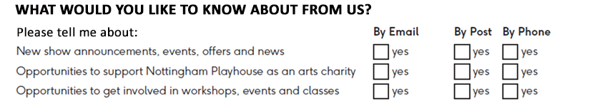

Our full privacy policy is available at nottinghamplayhouse.co.uk/site/privacy-policy


Instruction to your
bank or building society
to pay by Direct Debit
Please fill in the whole form using a ball point pen and send it to:
Nottingham Playhouse Trust Limited
Wellington Circus
Nottingham
NG1 5AF

 |  |  |  |  |  |  |  |  |  |  |  | Service user number
 |  |  |  |  |  |  |  |  |  |  |  | 4 |  | 1 |  | 7 |  | 8 |  | 9 |  | 6
Name(s) of account holder(s) |  |  |  |  |  |  |  |  |  |  |  | Reference
Instruction to your bank or building society
Please pay Nottingham Playhouse Trust Limited Direct Debits from the account detailed in this Instruction subject to the safeguards assured by the Direct Debit Guarantee. I understand that this Instruction may remain with Nottingham Playhouse Trust Limited and, if so, details will be passed electronically to my bank/building society.
Bank/building society account number
Branch sort code
Name and full postal address of your bank or building society
To: The Manager |  |  |  |  | Bank/building society
Address |  |  |  |  |  |  |  |  |  |  |  | Signature(s)
 |  |  |  |  |  | Postcode |  |  |  |  |  | Date
Banks and building societies may not accept Direct Debit Instructions for some types of account
DDI2

This guarantee should be detached and retained by the payer.

The
Direct Debit
Guarantee
- This Guarantee is offered by all banks and building societies that accept instructions to pay Direct Debits
- If there are any changes to the amount, date or frequency of your Direct Debit Nottingham Playhouse Trust Limited will notify you 10 working days in advance of your account being debited or as otherwise agreed. If you request Nottingham Playhouse Trust Limited to collect a payment, confirmation of the amount and date will be given to you at the time of the request.
- If an error is made in the payment of your Direct Debit, by Nottingham Playhouse Trust Limited or your bank or building society, you are entitled to a full and immediate refund of the amount paid from your bank or building society
– If you receive a refund you are not entitled to, you must pay it back when Nottingham Playhouse Trust Limited asks you to
- You can cancel a Direct Debit at any time by simply contacting your bank or building society. Written confirmation may be required. Please also notify us.

